Multiple-choice section – choose the correct answer

Question 1 [9.5]

Which one of the following statements is false?

A A parallelogram has two pairs of parallel sides.

B A square is a special type of rectangle

C The diagonals of a rhombus bisect each other at right angles.

D . A kite has opposite sides equal.

Question 2 [9.1]

Which is not a test for congruent triangles?

A AAA B SSS C RHS D ASA

Question 3 [9.1]

The value of x in the pair of similar triangles is:

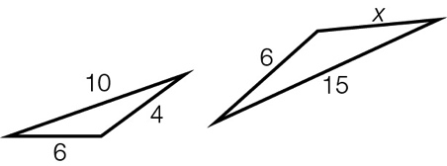

A 4 B 9 C 8 D 12

Question 4 [9.2]

with can be used as part of a test for congruency because:

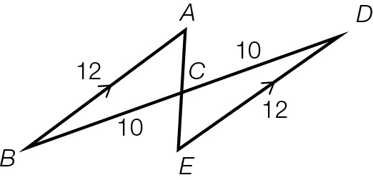

A they are alternate angles

B they are opposite angles

C their sum is 180°

D they are both acute angles

Question 5 [9.3, 9.5]

If OB = OC, which congruency test can be used to prove ≡?

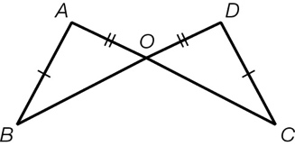

A SAS B ASA C SSS D RHS

Question 6 [9.2]

A pair of congruent triangles is:

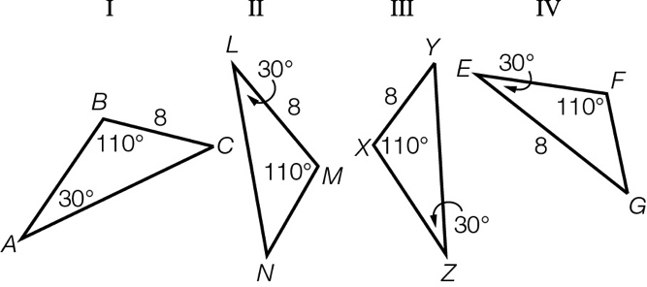

A II and III B I and IV C I and III D II and IV

Question 7 [9.4]

Which statement is false for the diagram shown?

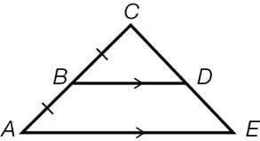

A  B 

C  D 

Question 8 [9.6] [10A]

What is the value of ?

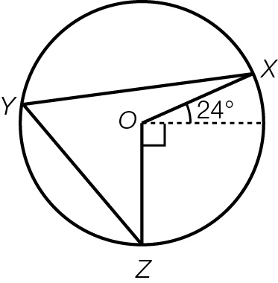

A 48° B 57° C 24° D 66°

Multiple-choice total marks: ____ / 8

Short answer section

Question 9 2 marks [9.2]

Use words from the list below to complete the following sentences.

bisect included angle definition perpendicular bisector

congruent similar theorem perpendicular

(a) The ____________________ is made by two lines with a common vertex.

(b) The ___________ of a scalene triangle is that all three sides are of different lengths.

Question 10 2 marks [9.2]

Explain the difference between two figures that are similar and two figures that are congruent.

Question 11 4 marks [9.1]

In and.

In .

(a) Explain why the two triangles are similar.

(b) What is the value of BC?

Question 12 2 marks [9.2]

Explain why testing two triangles for SAS does not guarantee congruency.

Question 13 3 marks [9.1]

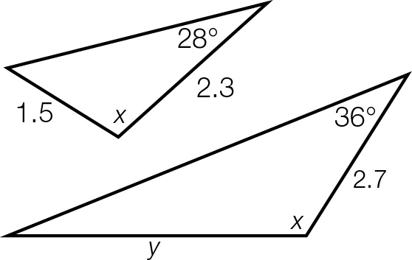Calculate the values of x and y if the pair of triangles shown are similar.

Question 14 3 marks [9.1]

The small triangles in the diagram are all equilateral.

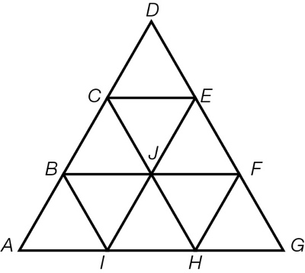

(a) Name two different-sized triangles that are similar to .

(b) Name two parallelograms that are congruent to *ACEI*.

(c) Name a shape that is congruent to *EFHIJC*.

Question 15 3 marks [9.3]

Prove that is similar to .

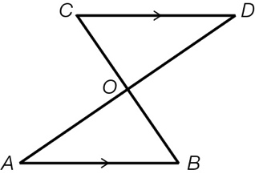

Question 16 5 marks [9.2]

A rectangular garden of dimensions 7 m × 2.4 m has been expanded proportionally so that the width  
is now 3.6 m.

(a) If the old garden shape and the new shape are similar figures, what is the length of the new garden?

(b) The garden will be enlarged again, with the new length being 17.5 m. What will be the width of the garden now?

(c) What dilation factor has been applied to enlarge the original garden to its final size?

Question 17 3 marks [9.3]

Show that when 

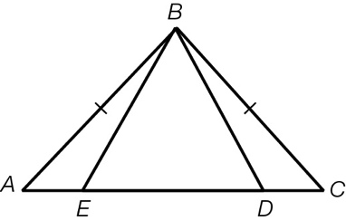

Question 18 3 marks [9.2]

A ladder rests on a 1.8 m wall with one end against a tree at a height of 7 m above the ground and the other end on the ground. If the wall is 0.6 m from the bottom of the ladder, find the:

(a) horizontal distance, in metres, correct to 2 decimal places, of the base of the ladder from the bottom of the tree

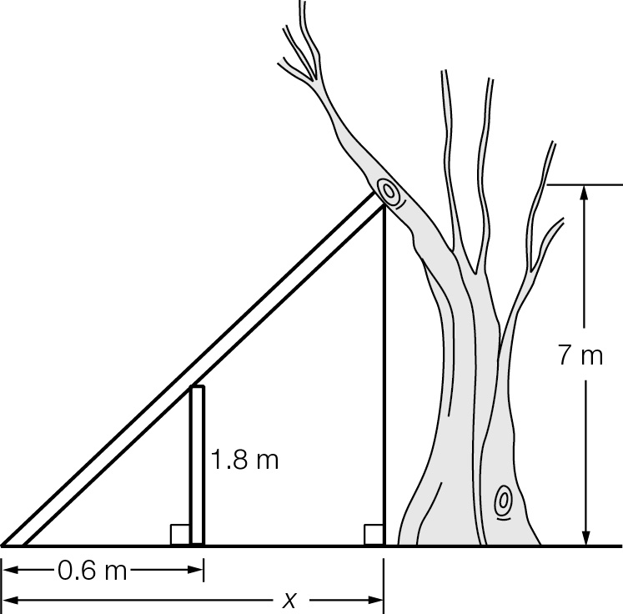

(b) horizontal distance, in metres correct to 2 decimal places, of the wall from the bottom of the tree.

Short answer total:_____ /30

Extended answer section

Question 19 5 marks [9.3]

and  are different-sized equilateral triangles.

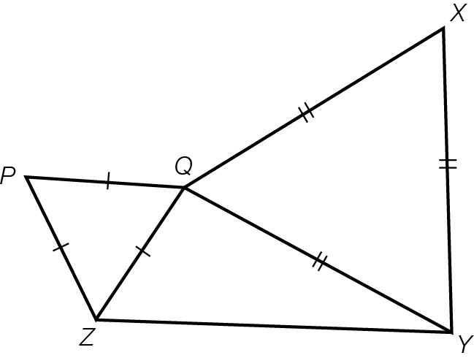

(a) Show that 

(b) Show that

(c) Hence, show that *YP* = *XZ*

Question 20 8 marks [9.2, 9.3]

In the diagram, AC = EC and BC = DC.

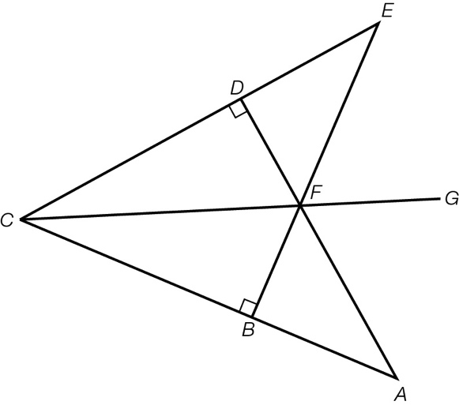

(a) Prove that 

(b) Prove that 

(c) Prove that CG bisects 

Question 21 6 marks [9.3]

 is an isosceles triangle, where *JK* = *LK* and *M* is the midpoint of *JL.*

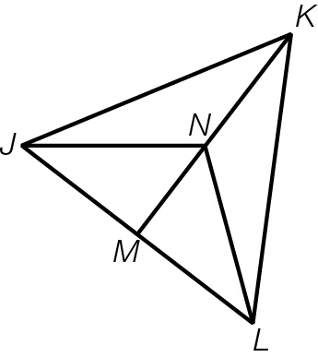

(a) Prove that 

(b) Prove that 

(c) Prove that 

Question 22 4 marks [9.6] [10A]

Point O is the centre of the circle. Show that:

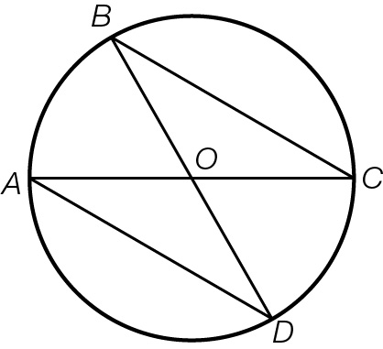

(a) 

(b) 

Extended answer total:_____ /23

TOTAL test results: _____ / 61